#### Assignment: Apply Four (4) R Functions to visually and statistically Explore a Categorical Variable and a Numeric Variable

R provides a vast array of functions to explore both categorical (qualitative) and numeric (quantitative) data. These R functions provide both visual representation as well as statistical descriptors of both types of data.

In this project, I used R and RStudio to explore visually and statistically one categorical variable and one numeric variable of an R built-in data set by applying four (4) R functions.

I Selected and introduced one categorical variable. I brought up the Species table in the data set, seen here:

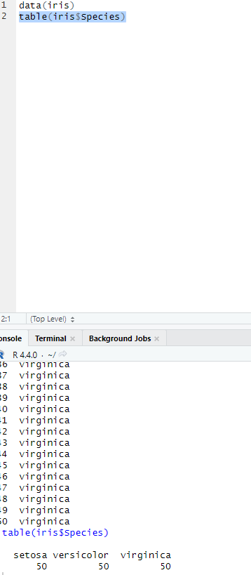

From here, I created a Barplot of the 3 Species types:

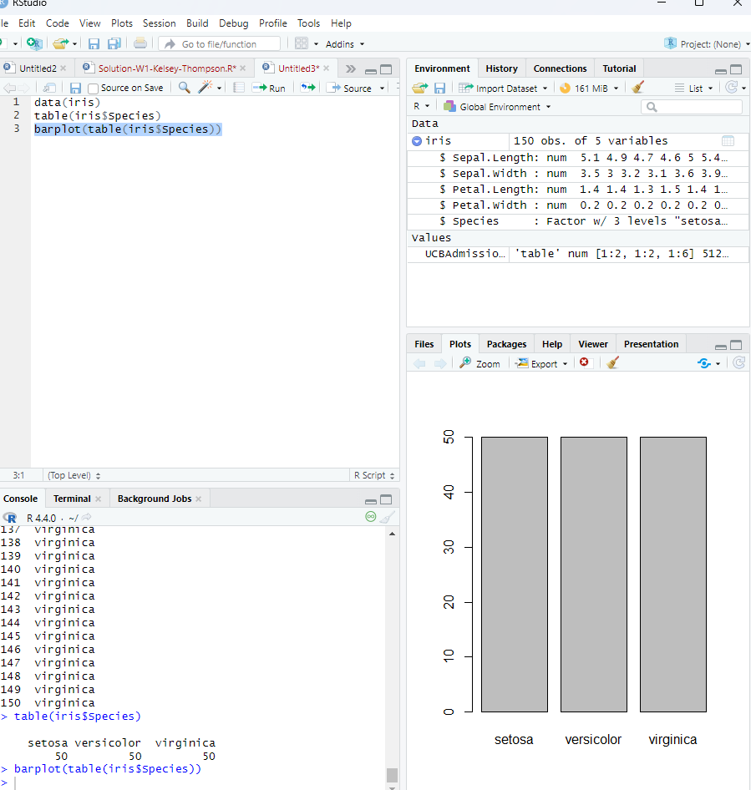

Here, I calculated the summary stats of the numeric variables (Petal_Width) below:

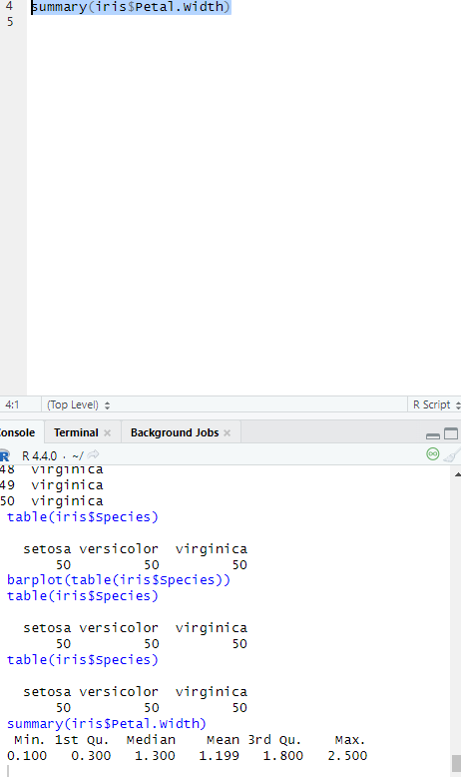

This variable of the R built-in data set that contains both categorical and numeric, is Sepal.Width. I explored one visual command, called a histogram:

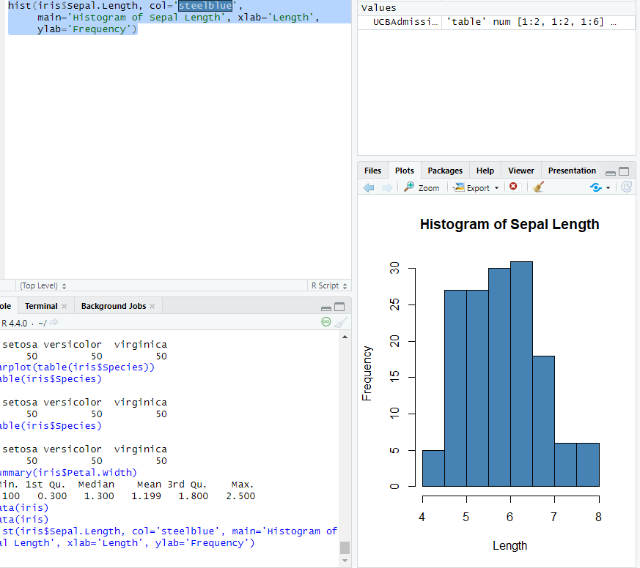

I also calculate the variance of Sepal.Length. The result is 0.6856935. See below:

